Distributed Databases
# Source: Chatgpt (GPT-5-Mini) at [1/16/2026]
A Distributed Database System (DDBS) is a type of distributed system where the database is stored across multiple physical locations (nodes or sites), but it appears as a single database to users and applications.
This system allows data sharing, redundancy, and parallel processing across multiple sites.

Definition
# Source: Chatgpt (GPT-5-Mini) at [1/16/2026]
A Distributed Database:
- Stores parts of the database at different locations
- Allows transparent access, so users don’t need to know the data’s location
- Supports concurrent access, replication, and synchronization

Architecture Diagram
# Source: Chatgpt (GPT-5-Mini) at [1/16/2026]
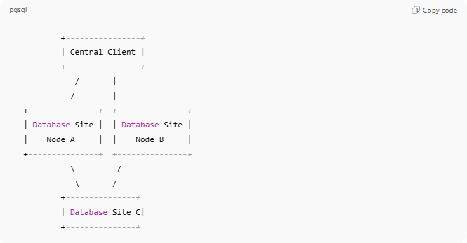
+----------------+
| Central Client |
+----------------+
/ |
/ |
+---------------+ +---------------+
| Database Site | | Database Site |
| Node A | | Node B |
+---------------+ +---------------+
\ /
\ /
+---------------+
| Database Site C|
+---------------+
- Each site stores part or all of the database
- Sites communicate to coordinate queries, updates, and transactions

Key Characteristics
# Source: Chatgpt (GPT-5-Mini) at [1/16/2026]
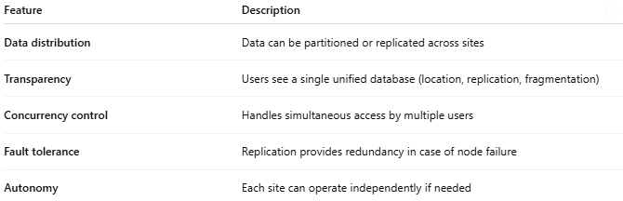
Feature | Description
Data distribution | Data can be partitioned or replicated across sites
Transparency | Users see a single unified database (location, replication, fragmentation)
Concurrency control | Handles simultaneous access by multiple users
Fault tolerance | Replication provides redundancy in case of node failure
Autonomy | Each site can operate independently if needed

How It Works
# Source: Chatgpt (GPT-5-Mini) at [1/16/2026]
- A user sends a query to the distributed database system
- The system identifies which sites store the relevant data
- Queries are executed locally at each site
- Results are collected and combined for the user

Advantages
# Source: Chatgpt (GPT-5-Mini) at [1/16/2026]
- Improved reliability (replication ensures fault tolerance)
- Better performance (parallel query execution)
- Scalability (add more nodes to handle growth)
- Data sharing across locations

Disadvantages
# Source: Chatgpt (GPT-5-Mini) at [1/16/2026]
- Complex design and management
- Harder transaction management (ensuring consistency across sites)
- Higher network overhead
- Difficult security management

Examples
# Source: Chatgpt (GPT-5-Mini) at [1/16/2026]
- Google Spanner (global distributed database)
- Amazon DynamoDB
- Apache Cassandra
- Oracle Real Application Clusters (RAC)

Simple Analogy
# Source: Chatgpt (GPT-5-Mini) at [1/16/2026]
- Distributed Database: A company has offices in multiple cities.
  - Each office keeps part of the records
  - Employees can access all records as if they were in one central office
  - Updates and changes are synchronized across offices

If you want, I can continue explaining other types of distributed systems based on purpose, like Distributed File Systems, Distributed Computing Systems, Distributed Real-Time Systems, etc., with diagrams and examples.
Do you want me to do that next?

